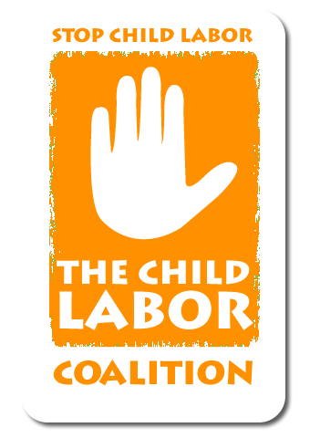
Child Labor Coalition Policy Intern
Full or Part Time
The National Consumers League is seeking a motivated intern who wants to work with a nonprofit advocacy group. The League is a national consumer and policy organization that protects and promotes social and economic justice for U.S. consumers.
The intern will assist NCL staff with ongoing projects and research related to the Child Labor Coalition (CLC), which includes 37 organizational members and serves as a national network for the exchange of information about child labor; provides a forum and a unified voice on protecting working minors and ending child labor exploitation; and develops informational and educational outreach to public and private sectors to combat child labor abuses and promote progressive initiatives and legislation.
The CLC’s domestic agenda includes several legislative initiatives to protect working youth, with specific focus on children working as migrant and seasonal farmworkers, child trafficking for sex work and forced labor, and children in other worst forms of child labor—both in the U.S. and abroad.
This internship will provide an opportunity to:
- Gain knowledge about child labor issues, both international and domestic;
- Become familiar with various non-governmental groups and relevant government agencies, and their role in addressing child labor issues;
- Lobby congressional staffers to advance legislation to protect farmworker children;
- Provide basic research tasks;
- Understand coordination and management of a national coalition; and
- Help us monitor on social media child labor developments and write about them in blogs.
We ask that interns make a minimum time commitment of six weeks, spending at least 20 hours per week working at the League. We welcome longer time commitments. Our goal is to tailor your internship to suit your specific needs.

Our office is centrally located in Washington, D.C., three blocks from the White House and on DC Metro’s red, blue, orange, and silver lines. Intern housing may be available independently at George Washington University, which is nearby.

Please submit cover letter, résumé, and writing sample to subject: Child Labor Policy Intern via email: reidm@nclnet.org .

